Diagnostic Medicare Center Management System
Software Requirements Document
V 1.0


 | Prepared By | Reviewed by | Approved By
Name | Nikhil
Role | Team member | Project Leader/ Team Leader/ Team Member | Project Manager/ Team Leader
Signature | Nikhil
Date | 27/11/2014

Table of Contents
1.0 Introduction 3
1.1 About this document 3
1.1.1 Purpose & Scope of the document 3
1.1.2 Intended Audience 3
1.2 About the Software System 3
1.2.1 Purpose 3
1.2.2 Scope of the system 4
1.2.3 Exclusions 5
1.2.4 System Perspective 5
1.2.5 System diagram 5
1.2.6 Architecture diagram 5
1.2.7 System Environment 7
1.2.8 User Characteristics 7
1.2.9 Impact of the System 7
1.2.10 Assumptions, Risks / Constraints 8
1.2.11 Design Constraints 8
2.0 System Requirements 9
2.1 Functional Requirements 9
2.1.1 Home Module 9
2.1.1.1 Create account Module 9
2.1.2 Search Medicare Service 11
2.1.3 Apply Health Checkup 13
2.1.4 Medical Insurance agent and services 15
2.1.5 Medical Reports Online Module 16
2.2 Nonfunctional Requirements 18
2.2.1 UI Requirements: Inn 18
2.2.2 Performance Requirements: Pnn 18
2.2.3 Installation, Deployment & Operational Requirements: Onn 19
2.2.4 Maintainability & Portability Requirements: MPnn 19
2.2.5 Security Requirements Snn: 19
3.0 Requirements / Use Case Summary Table 19
4.0 Make /Buy analysis 20
4.1 Reusable components 20
5.0 Annexure 20
6.0 Change Log 20

Introduction

About this document

Purpose & Scope of the document
The purpose of the software requirements document is to systematically capture requirements for the project and the system “Diagnostic Medicare center Management System” to be developed. Both functional and non-functional requirements are captured in this document. It also serves as the input for the project scoping.
The scope of this document is limited to addressing the requirements from a user, quality, and non-functional perspective. It is recommended that design aspects are not added in this document

Intended Audience
Project Team

About the Software System
The client would like to develop an independent application Diagnostic Medicare center Management System (DMS) website which is used for creating an account for the new customer, to search for a Medicare service, apply for any health checkup, to find a medical insurance agent and services and to view the medical reports online.
The following section will cover aspects related to Diagnostic Medicare center Management System.

Purpose
DMS is a system used for maintaining the details of the Diagnostic Medicare center like creating an account for the customer who wants to be a member of the Diagnostic center, to search for a Medicare service, to apply for any health checkup, to find a medical insurance agent and services and to view the medical reports online The following are the few important modules in the system
- To create an account for the new customer
- To search for any Medicare service.
- Apply for any health checkup
- To find an medical Insurance agent and services
- To view the medical report online.

Scope of the system
The scope of the system is explained through its modules as follows
- Create account – will be used by the customer to create an account when they want to be a member of the Diagnostic center.
- Search Medicare Service- will be used by the customer to search for a Medicare service that is available.
- Apply Health Checkup– will be used by the customer to apply for the health check that they are in need.
- Medical Insurance agent and services - will be used by customer to talk to a medical insurance agent to get the medical policy details.
- Medical Reports Online – will be used by the customer/Doctor wants to
View the medical reports

Use Case Diagram

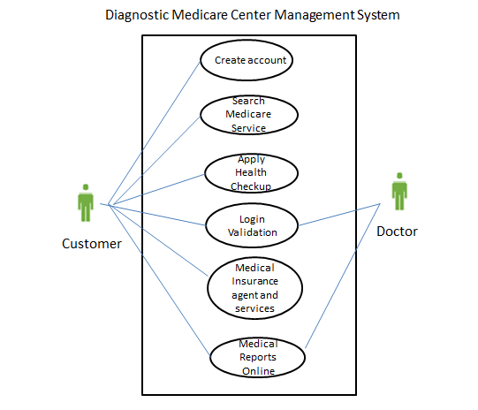

Exclusions
The system will operate only on the modules discussed above and will not include any additional functionality.

System Perspective
DMS is an independent software system developed to manage the activities like Create account, Search Medicare Service, Apply Health Checkup, Medical Insurance agent and services and Medical Reports Online.

System diagram
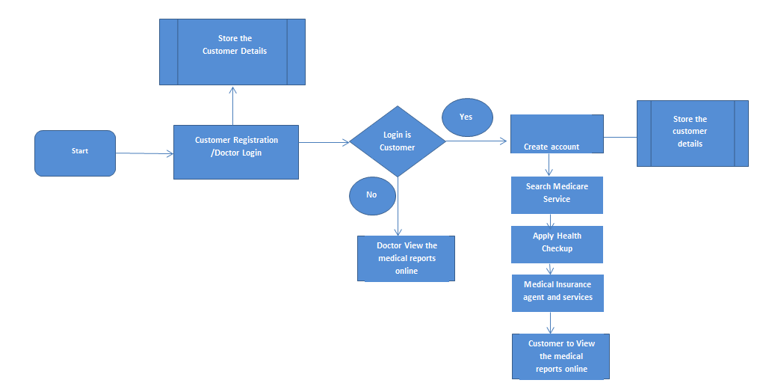

Architecture diagram

Physical Architecture:
A physical architecture is an arrangement of physical elements, (system elements and physical interfaces) that provides the designed solution for a product, service, or enterprise. It is intended to satisfy logical architecture elements and system requirements. Auto Identification Process follows a three layered architecture namely presentation layer, business logic layer and data access layer.
- Presentation Tier is the tier in which the users interact with an application. Presentation Tier contents Shared UI code, Code Behind and Designers used to represent information to user.
- Business Tier is mainly working as the bridge between Data Tier and Presentation Tier. All the Data passes through the Business Tier before passing to the presentation Tier. Business Tier is the sum of Business Logic Layer, Data Access Layer and Value Object and other components used to add business logic.
- Data Tier is basically the server which stores all the application’s data. Data tier contents Database Tables, XML Files and other means of storing Application Data.
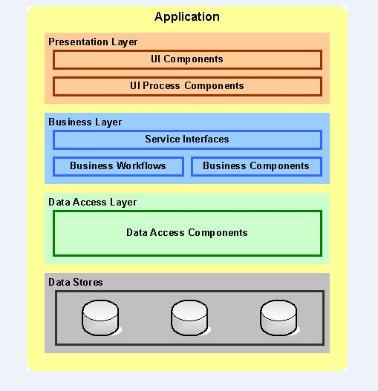

Logical Architecture:
The Logical Architecture defines the Processes (the activities and functions) that are required to provide the required User Services. Many different Processes must work together and share information to provide a User Service. The Processes can be implemented via software, hardware, or firmware. The Logical Architecture is independent of technologies and implementations

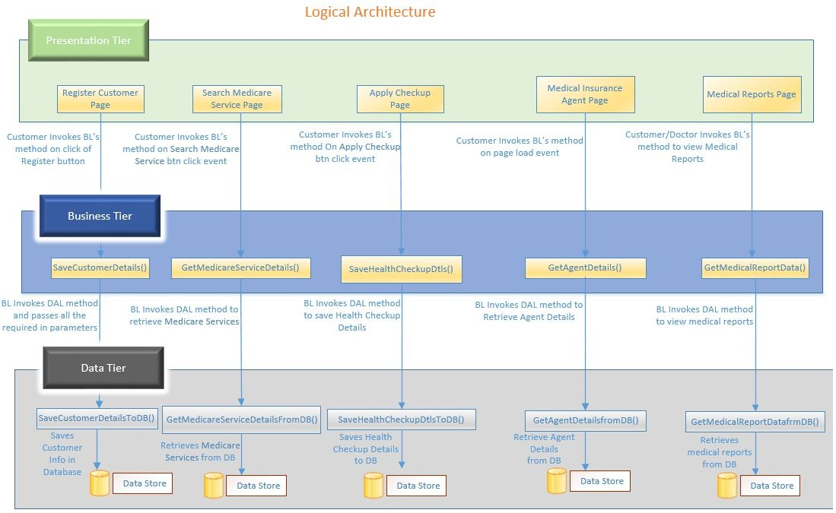

System Environment
The Diagnostic Medicare center Management system web site will be operated from the client server with parallel processor support. When a user connects to the Web Server, the Web Server will interact with the Database after processing the business logic to transfer data to and from a database.
- Java/J2EE or .NET Framework application deployment.
- My Sql/Sql server database for data storage.

User Characteristics
The application should be user friendly; hence the user should not need any software and hardware knowledge. The user may be new to the client products having never used them before.
The types of users likely to use the system are as follows,
- Client
- Delivery Assurance Group, Process Engineering group
- Developers, testers, other associates in the project

Impact of the System
This is a new product which is developed for internal users. Expected impact of the product is to automate existing manual processes in order to make them more efficient and cost effective.

Assumptions, Risks / Constraints
Assumptions:
The DMS customer must possess transaction data along with their default status for all the agents.
Risks:
If there is any failure in making diagnosis, the system should be able to handle such a financial risk.

Design Constraints
- Application should have single login feature. Login functionality should be the welcome feature for the application.
- Only administrator and customers can access the application.
- None of the application features can be accessed without login.

System Requirements

Functional Requirements

Home Module
Diagnostic Medicare Center Management system  Req-2.1.1 | Home Page
Functional Requirements
- When the users enter the following link http://localhost/DiagnosticMedicareManagementsystem in the browser, Home page appears which will have a short welcome message; a brief introduction to the purpose of the Diagnostic Medicare center Management System, the user can choose appropriate options. Under home page, we need below interface.
Home page Interface Requirements
- Customer
- About Us
- Contact Us

2.1.1.1 Create account Module
Diagnostic Medicare Center Management system  Req-2.1.1.1 | Customer - Registration
Functional Requirements
When the customer clicked on the registration link, it should re-direct to registration form and the customer need to fill some of the basic attributes/fields as mentioned below in requirement;
User Id, Password, Date of Birth , Email ID

By default Customer will have both read access and write access.
Any given point of time, the customer can deselect all or can go to home page by the clicking home.
User Interface Requirements
- User Id – Customer should enter the user id
- Password – The customer should able to provide the password with( Combination of at least one number, one lowercase, one uppercase letter and at least eight characters)
- Date of Birth – The customer should able to enter the DOB in DD/MM/YYYY
There should be 2 buttons i.e. Register, reset
Trigger - When Customer wants to get registered to the portal.
Post Conditions - The customer details get registered in the database successfully so that the customers can login into the system.
Success End Condition - A success message should be displayed saying ‘Your account has been created successfully! Your account will be activated once the system administrator approves your account’.
Failed End Condition - The system should throw an error message if one of the validations fails. ‘Error in creating your account. Contact System Administrator’ message should be displayed
Steps & Actions
- When the Customer selects the “New Registration” option, the system should allow the below inputs from the user.
  - User Id
  - Password
  - Date of Birth
  - Email ID

- Created Date should be taken from the system.

- System should save the above details into the respective table in the database.
- System must check for validations which are given below.

Business Rules & Validations
- All fields are mandatory.
- User Id should be a number and must be 6 digits long.
- Password length should have minimum 8 chars and max 20 chars, at least 1 special chars and at least 1 number.
- Date of birth of the customer should be entered by the customer in the below format.
  - 2000/06/23 – Date format – YYYY/MM/DD
- Email ID of the customer should be validated.

Search Medicare Service
Diagnostic Medicare center Management system  Req-2.1.2 | Search Medicare service
Functional Requirements
When the customer clicked on the Search Medicare Service Link, it should re-direct to page to search for the Medicare service the customer is in need of.
Any given point of time, the customer can deselect all or can go to home page by the clicking home.
User Interface Requirements
Search : The customer should be able to search for the Medicare service they are in need of.
Trigger - Customers triggers the functionality once he/she submits the details into the system
Post Conditions - While making a search under Medicare Service all the service names under it should be populated from the database.

Success End Condition - Display the search result once the searching is completed.
Failed End Condition - The system should throw an error message if any one or more of the validations fail.

Steps & Actions
- System should display all the necessary fields.

- System need to display the Medicare service names, service features, service benefits.

- All the necessary validation should be done.

- Identify the MEDICARESERVICE_MASTER table storing the available service names.

- Identify the MEDICARESERVICE_DETAILS table storing the service details briefly

Table: MEDICARESERVICE_MASTER

Service_id | Service_Name
1000 | Digital X-Ray
1002 | Eye Check-up
1003 | Total Body Fat analysis
1004 | 3D Color Droppler

Table: MEDICARESERVICE_DETAILS

Service_Id | Service_name | Service_ Features | Service_Benefits | Service Parameters
1000 | Digital X-Ray | To find issues in the bone and Body. | Complete check up | - Digital machines  - Dental Radiography  - Routine Radiography
1002 | Eye Check-up | To find issues in the Eyes | Complete check up | - Ophthalmic room  - Qualified MS Doctors
1003 | Total Body Fat analysis | To find the total fat available in body | Complete check up | - Fat analyser from USA
1004 | 3D Colour Dropper | To evaluate normal and abnormal fetal hearts. | Complete check up | - Latest machine from GE  - Vaginal & Trans Rectal studies  - Paediatric studies

Business Rules & Validations
- Medicare service search option should be displayed.
- Search the services under the Medicare service option
- On selecting each service the Service_ Features, Service_Benefits, and Service Parameters, should be displayed.

Apply Health Checkup
Diagnostic Medicare center Management system  Req-2.1.3 | Apply Health Checkup
Functional Requirements
When the customer clicked on the Apply Health checkup link, it should re-direct to where the customers can have a request for the health checkup plan they are in need of..
Any given point of time, the customer can deselect all or can go to home page by the clicking home.
User Interface Requirements
Search: The customer should be able to search for the Health checkup plan they are in need of.
Select: The customer should be able to select the checkup plan once they have searched for it.
Apply : The customer should be able to apply for the checkup plan once they have selected for it.

Trigger - Candidate triggers the functionality once he/she submits the details into the system.
Post Conditions - The entire detailed list of the health check-up that is selected by the customer should be displayed.

Success End Condition - : If applying of the health checkup plan is successful the detailed list of the health checkup will be displayed.
Failed End Condition - The system should throw an error message if any one or more of the validations fail. The error messages and error codes need to be identified during design. The validation and business rules are mentioned in the business rules section.

Steps & Actions
- Registered customer logs into the system.
- Search for the health check-up that the customer is in need of.
- System need to render the health check-up details depending on search criteria.
- All the necessary validation should be done.
- User will select one of the Health checkup plan and proceed for applying for it.
- Applying for the health checkup will generate the nomination form to apply for the health checkup.
- Identify the table for storing the nomination details.

Table: NOMINATION_DETAILS
ID | Name | D.O.B | Email Address | Mobile Number | Country | State | City Name | Pin Code | Health Plan Name
1000 | X | 01/02/1988 | XCV@gmail.com | 987415622 | India | Tamil Nadu | Chennai | 600099 | Basic Health check-up
1001 | Y | 02/06/1987 | ABC@gmail.com | 897456123 | India | Tamil Nadu | Chennai | 600050 | Executive Health check-up
1002 | Z | 05/08/1985 | UBC@gmail.com | 568974413 | India | Tamil Nadu | Chennai | 600023 | Supreme Health check-up
Table: HEALTHPLAN_DETAILS
HealthPlan_ID | Health Plan Name | Detailed Constitutes under each plan | Number of days for check up | Price
201 | Basic Health check-up | *Complete Blood Count *ESR  *Blood Group & Rh Factor | 1 | 500
202 | Executive Health check-up | *Total Cholesterol  *HDL Cholesterol  *LDL Cholesterol  *VLDL Cholesterol | 2 | 500
203 | Supreme Health check-up | *Glucose Fasting  *Glucose Postprandial  *Glycosylated Hb/HbA1C | 1 | 700

Business Rules & Validations
- Name should be only of characters.
- Date of birth should be in a selective option, where in the customer can select the date, month and year.
- Email Id must be contains @ and. symbol.
- Mobile Number should be entered in numerals
- Email ID and the mobile number should be validated whether it is valid one provided by the customer.
- Country should be a drop down option where in the associates can select the respective country
- State should be a drop down option where in the associates can select the respective country
- City name should be entered, only characters should be allowed.
- VALID Pin code should be entered, only numerals are allowed.
- The Health plan name should be a drop down option where in the customer can select the health plan.
- There should be two options ‘I agree’ and ‘I do not agree’ since the customers will check their personal information provided in the nomination form.
- If the customer click ‘I do not agree’ the customer should be navigated to the home screen.
- There should be a SUBMIT option to submit the details where the Medicare service management team will look into and will call the customers accordingly.

Medical Insurance agent and services
Diagnostic Medicare Center Management system  Req-2.1.4 | Medical Insurance agent and services
Functional Requirements
When the customer clicked on the Medical insurance agent and services link, after entering all the details customer can select the agent to know about the medical insurance policy
Any given point of time, the customer can deselect all or can go to home page by the clicking home.
User Interface Requirements:
User id : Customer should be able to enter the User id
Password: Customer should be able to enter the password.
Select: The customer should be able to select the option to find out the medical insurance agent.
Location details: The customer should be able to enter the location details from where they need the medical insurance agent.

Trigger - Customer triggers the functionality once he/she wants detailed information about the policies
Post Conditions - The agent details will be retrieved from the database.

Success End Condition - Display the agent details
Failed End Condition - The system should throw an error message if one of the validations is wrong. The error message and error code needs to be identified during design. The validation and business rules are mentioned in the business rules section.

Steps & Actions
- Registered user should login to the system.
- Select the option ‘To find a medical insurance agent’.
- Provide the Location details.
- System should display all the necessary field details.

Business Rules & Validations
- Select ‘Medical insurance agent’ in the home screen.
- The option ‘Medical insurance agent’ will direct to the screen to find out the details about the agent.
- The details about the agents asked for will be ‘Street Address’,’City’,’State’,’Zip Code’.
- Valid details should be entered else error message will be displayed based on the invalid field
‘Please enter a valid zip code or city/state.’
- After giving valid details a list of available agents will be listed out available along with their contact number so the customer can contact him and ask for more details.

Table: AGENT_DETAILS

AGENT_ID | AGENT_NAME | STREET_ADDRESS | Mobile Number | CITY | STATE | ZIPCODE
A1 | Adam | Rd Street | 4545641231 | Chennai | Tamil Nadu | 600099
A2 | Jack | Nehru street | 121212312 | Bangalore | Karnataka | 600055
A3 | Nishan | HJY Street | 5665565665 | Chennai | Tamil Nadu | 600023
A4 | Rahul | GVC Street | 4542121 | Kerala | Kerala | 600078

Medical Reports Online Module
Diagnostic Medicare Center Management system  Req-2.1.5 | Medical reports online
Functional Requirements
When the customer clicked on the Medical reports online link, after entering all the details customer/doctor can view the medical reports online.
Any given point of time, the customer can deselect all or can go to home page by the clicking home.
User Interface Requirements:
User id: The customer/doctor should be able to enter the user name.
Password: The customer/doctor should be able to enter the password.
Report id : The customer/doctor should be able to enter the report id to search for the particular medical report they are in need of.

Trigger - Candidate triggers the functionality once he/she submits the details into the system

Post Conditions - The entire detailed report for the customer will be displayed.

Success End Condition - When the report ID is provided by the customer or the doctor the detailed list of the report will be displayed.
Failed End Condition - The system should throw an error message if any one or more of the validations fail. The error messages and error codes need to be identified during design. The validation and business rules are mentioned in the business rules section.

Steps & Actions
- When the user selects the View report option the screen should show the required fields username, password and the Logging as – the options will be Customer and Doctor.
- Registered customer/doctors logs into the system.
- Search for the report the customer/doctor is looking for by giving the report id.
- System need to render the report details depending on search criteria.
- Identify the table for storing the report details

Table: REPORT_DETAILS
Report_ ID | Customer Name | D.O.B | Email Address | Mobile Number | Doctor name | Diagnosis | Result
R1 | X | 01/02/1988 | XCV@gmail.com | 987415622 | Hari | Sugar test/Blood Test
R2 | Y | 02/06/1987 | ABC@gmail.com | 897456123 | Gopal | Blood test/ Cholesterol test
R2 | Z | 05/08/1985 | UBC@gmail.com | 568974413 | Priya | Cholesterol test

Business Rules & Validations
- Report ID should be of 2 character, the first character should be an alphabet and the second character should be number.
- Customer Name should be only of characters.
- Date of birth should be in a selective option, where in the customer can select the date, month and year.
- Email Id should be entered.
- Mobile Number should be entered in numerals
- Doctor Name should be only of characters.
- Diagnosis names should be characters which lists all the tests the customer has taken
- Result is the complete test result provided by the Medicare services.

Nonfunctional Requirements

UI Requirements: Inn
- The front end should be user-friendly and pleasant
- Any error message or exception displayed to the user should be user-readable (and not technical)
- All entered values should be validated
- The UI screens are designed with any theme color along with the logo of the company.
- Exceptions should not be shown on console.
- No debug message should come on console.
- All the errors and exceptions should be logged to log file.
- Log file path should be configurable.
- Database connections should be configurable.
- It should not be hard coded.
- Requirements involving UI features should be taken care in console accordingly

Performance Requirements: Pnn
- All front-end pages should be served up in less than 5 seconds post click when up to 1000 users are on the application concurrently.
- Since it’s a financial operations application, transactions should be safe and fast.

Installation, Deployment & Operational Requirements: Onn
- Application Java and J2EE deployment with My SQL database or SQL Server database for persistence
Or
Application .NET Framework deployment with SQL Server database for persistence
- This system must be up 24X7

Maintainability & Portability Requirements: MPnn
- If the allocated memory space for the existing application needs to be increased then it should be possible without any impact to performance

Security Requirements Snn:
- No unauthorized users should be able to log on to the system
- User Id/Login Id should have combination of letter and numeric values, none of the special characters are allowed (#,@,$,%,&).
- Validate the user id/login id and password, accordingly to the user it will redirect to the appropriate page.

Requirements / Use Case Summary Table
Business Requirement ID | Software Requirements ID | Short Description | Requirement Provider (Originator) | Priority | Complexity | Requirement type | Remarks
BR001 | SR001 | To Create an account | Client | High | Medium | UI screen & backend processing | -
BR002 | SR002 | To search for the medicare service | Client | Medium | Medium | UI screen & backend processing | -
BR003 | SR003 | Apply for health checkup plan | Client | High | Medium | UI screen & backend processing | -
BR004 | SR004 | Medical insurance agent and services | Client | Medium | Medium | UI screen & backend processing | -
BR005 | SR005 | Medical reports Online | Client | High | High | UI screen & backend processing | -

Make /Buy analysis

Reusable components
The DMS can be made reusable as such to handle agents.

Annexure
NA

Change Log
Please note that this table needs to be maintained even if a Configuration Management tool is used.
Version Number | Changes made
V1.0 | First version developed by Nalini on Nov 17 2014.
V1.1 | <If the change details are not explicitly documented in the table below, reference should be provided here>
V1.1 | Page no | Changed by | Effective date | Changes effected
V1.2 | <If the change details are not explicitly documented in the table below, reference should be provided here>
V1.2 | Page no | Changed by | Effective date | Changes effected

